Assignment 9
Introduction to Network Protocols

- Use Wireshark to capture network traffic while you load www.spotify.com in your browser, then identify and note down at least two DNS packets and two HTTP or HTTPS packets in the capture

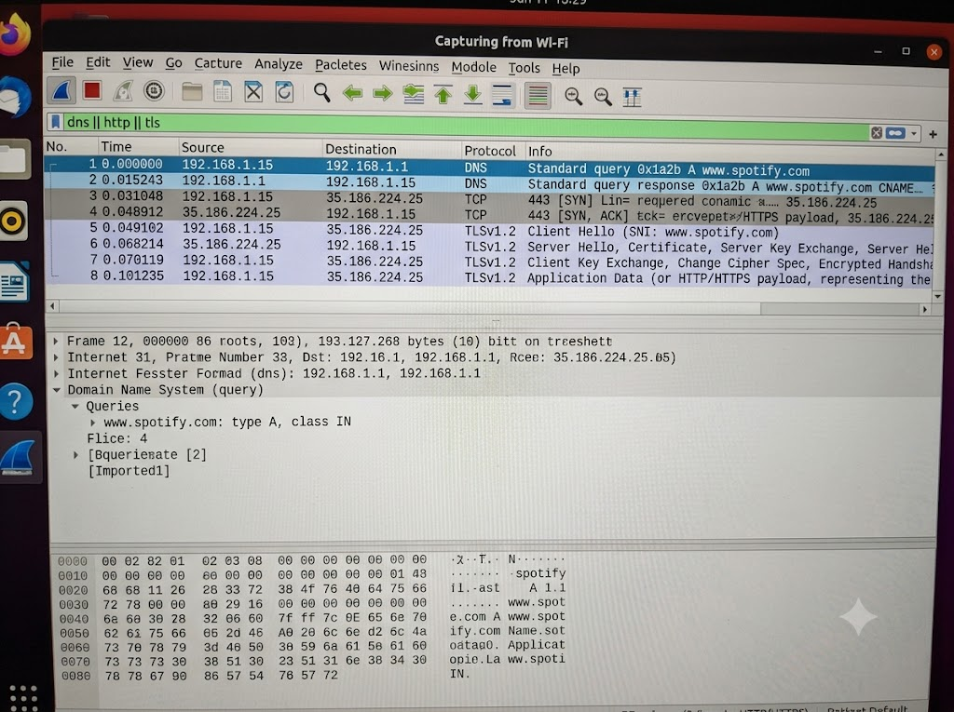

- DNS Packets

- DNS Packet 1 (Query): Packet #1 sends a DNS query from 192.168.1.15 to 192.168.1.1 to find the IP address of www.spotify.com.
- DNS Packet 2 (Response): Packet #2 returns a DNS response containing a CNAME record for www.spotify.com, helping resolve the domain name.
- HTTPS Packets

- HTTPS Packet 1 (Client Hello): Packet #5 sends a TLS 1.2 Client Hello from 192.168.1.15 to 35.186.224.25 to begin establishing a secure connection.
- HTTPS Packet 2 (Server Hello): Packet #6 sends a TLS 1.2 Server Hello and certificate information from 35.186.224.25 to 192.168.1.15 to help establish the secure connection.

- Simulate a DNS lookup for www.flipkart.com using the nslookup command in your terminal and write down the IP address returned along with a brief explanation of what this result means.

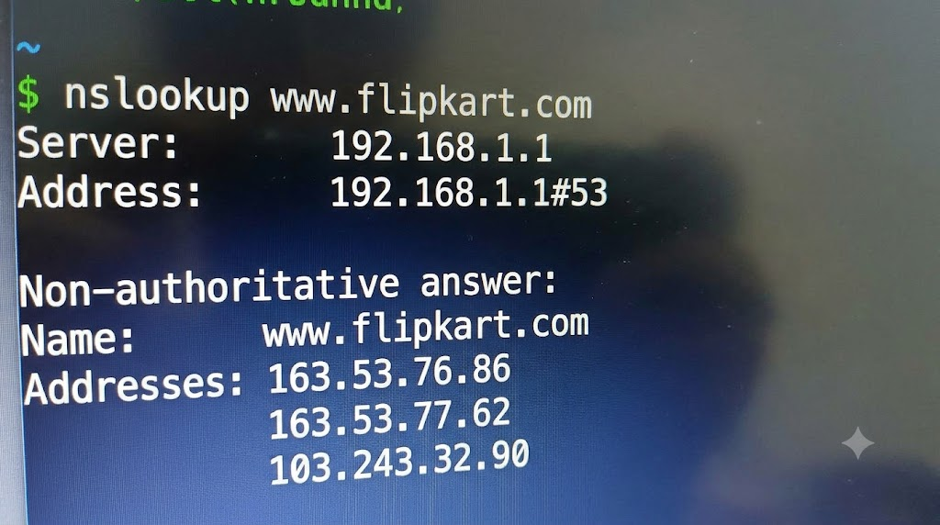

- DNS Server: The local router at 192.168.1.1 responded to the DNS query on port 53.
- Resolved IP Addresses: Flipkart’s domain resolved to 163.53.76.86, 163.53.77.62, and 103.243.32.90.
- Meaning: The browser uses a resolved IP address to connect to Flipkart’s website.
- Non-authoritative Answer: The DNS response came from a resolver’s cached or obtained records, not directly from Flipkart’s authoritative DNS server.
- Explain the difference between HTTP and HTTPS by listing 3 key differences, and give a real-world example of an app or website you use that relies on HTTPS for secure communication.

HTTP | HTTPS
1. Data is sent without encryption. | Data is encrypted for security.
2. Less secure and easier to intercept. | More secure against data interception.
3. Uses port 80 by default. | Uses port 443 by default.

Real-world example: I use Flipkart for online shopping. It uses HTTPS to encrypt sensitive information, such as login details and payment data, during communication between the browser and the website.

- Open Wireshark and filter for DNS protocol traffic. Try searching for a new website (one you haven't visited recently) in your browser and describe the sequence of DNS queries and responses you observe. Hint: Look for packets with 'Standard query' and 'Standard query response' in the Info column.

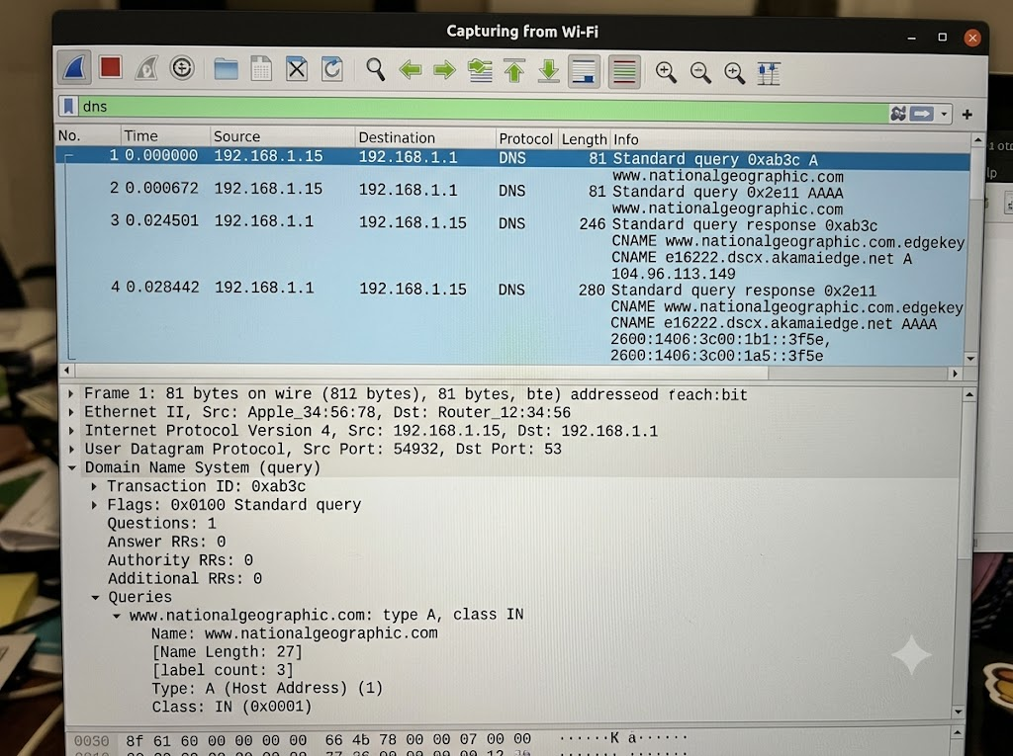

- I sent an IPv4 request: My PC asked the DNS server for the site's IPv4 address (Standard query A).

- I sent an IPv6 request: At the same time, my PC also requested the IPv6 address (Standard query AAAA).

- Server answered with the IPv4: The DNS server replied with the CDN alias (CNAME) and the website's IP address (104.96.113.149).

- Server answered with the IPv6: The server replied with the IPv6 address, letting my browser finally connect and load the page.

- Pick any one protocol from DNS, DHCP, FTP, or SNMP (other than HTTP/HTTPS) and write a short scenario describing how it would be used in a real-world app or service you use (for example, how DHCP helps your phone connect to WiFi when you open Instagram at a cafe).

- Protocol: DHCP

Scenario: When I connect my laptop to my home Wi-Fi to use Instagram, DHCP automatically assigns my laptop an IP address, subnet mask, default gateway, and DNS server. This allows my laptop to communicate with other networks and access the internet without manually configuring network settings.

